FEP-II

Extra Practical Assignment-I

Batch-A3

Marks: 10

Perform following task:

* Create a new empty project by the name ‘Data’ with API 22. (1 M)
* Design an application using Linear Layout with components TextView, EditText, 2 sets of RadioButton and ImageButton. (3 M)
* On Button click, fetch the user entered values from all UI components and place them on a TextView in the same activity. (3 M)
* On click of the Result TextView, switch from screen 1 to screen 2 and display a random message. (2 M)
* Deploy the application on API 30. (1 M)

**Solutions:-**

1. **Create a new empty project by the name ‘Data’ with API 22. (1 M)**

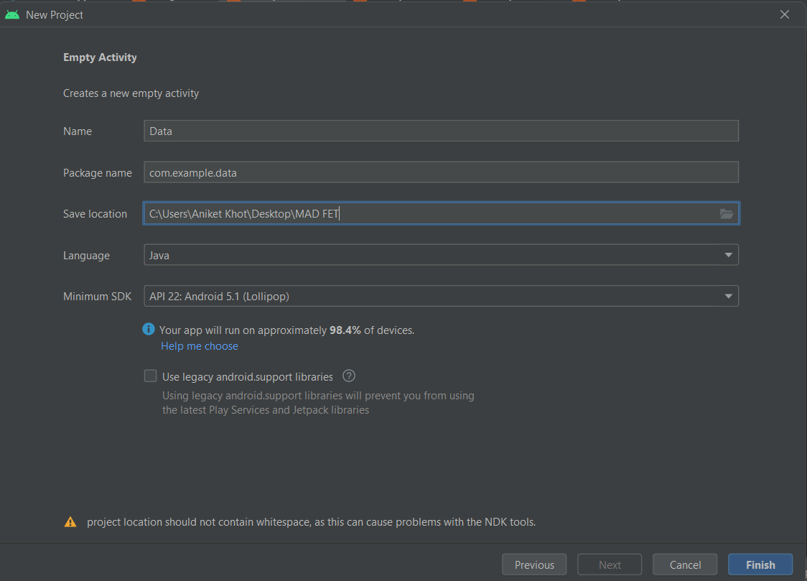

1. **Design an application using Linear Layout with components TextView, EditText, 2 sets of RadioButton and ImageButton. (3 M)**

**MainActivity.java**

package com.example.data;

import androidx.appcompat.app.AppCompatActivity;

import android.annotation.SuppressLint;

import android.content.Intent;

import android.os.Bundle;

import android.view.View;

import android.widget.Button;

import android.widget.EditText;

import android.widget.ImageButton;

import android.widget.RadioButton;

import android.widget.RadioGroup;

import android.widget.TextView;

public class MainActivity extends AppCompatActivity {

EditText nameOfUser;

ImageButton b;

TextView resultEntered;

RadioGroup gender, year;

RadioButton genderEntered,yearEntered;

@SuppressLint("MissingInflatedId")

@Override

protected void onCreate(Bundle savedInstanceState) {

super.onCreate(savedInstanceState);

setContentView(R.layout.activity_main);

nameOfUser=findViewById(R.id.name);

b=findViewById(R.id.nextButton);

resultEntered=findViewById(R.id.result);

gender=findViewById(R.id.gendergroup);

year=findViewById(R.id.yeargroup);

b.setOnClickListener(new View.OnClickListener() {

@Override

public void onClick(View view) {

int radioIDGender=gender.getCheckedRadioButtonId();

genderEntered=findViewById(radioIDGender);

String genderFinal = genderEntered.getText().toString();

int radioIDYear=year.getCheckedRadioButtonId();

yearEntered=findViewById(radioIDYear);

String yearFinal = yearEntered.getText().toString();

String nameUser=nameOfUser.getText().toString();

resultEntered.setVisibility(View.VISIBLE);

resultEntered.setText("Name: "+nameUser+" \nGender: "+genderFinal+" \nYear: "+yearFinal);

}

});

}

public void onClick(View v){

String randomMessage= "Hello World! This is the random message Generated. :)";

Intent i= new Intent(MainActivity.this,ResultActivity.class);

i.putExtra("random",randomMessage);

startActivity(i);

}

}

**Activity_main.xml**

<?xml version="1.0" encoding="utf-8"?>

<LinearLayout xmlns:android="http://schemas.android.com/apk/res/android"

xmlns:app="http://schemas.android.com/apk/res-auto"

xmlns:tools="http://schemas.android.com/tools"

android:layout_width="match_parent"

android:layout_height="match_parent"

android:orientation="vertical"

tools:context=".MainActivity">

<LinearLayout

android:layout_width="wrap_content"

android:layout_height="wrap_content"

android:layout_marginLeft="30dp"

android:layout_marginTop="30dp"

android:orientation="horizontal">

<TextView

android:id="@+id/nameText"

android:layout_width="wrap_content"

android:layout_height="wrap_content"

android:layout_weight="1"

android:text="Enter Name: " />

<EditText

android:id="@+id/name"

android:layout_width="wrap_content"

android:layout_height="wrap_content"

android:layout_marginLeft="50dp"

android:hint="Enter Name Here" />

</LinearLayout>

<TextView

android:id="@+id/selectGender"

android:layout_width="wrap_content"

android:layout_height="wrap_content"

android:layout_marginLeft="30dp"

android:layout_marginTop="20dp"

android:text="Select Gender" />

<RadioGroup

android:id="@+id/gendergroup"

android:layout_width="258dp"

android:layout_height="92dp"

android:layout_marginLeft="30dp"

app:layout_constraintBottom_toBottomOf="parent"

app:layout_constraintEnd_toEndOf="parent"

app:layout_constraintHorizontal_bias="0.425"

app:layout_constraintStart_toStartOf="parent"

app:layout_constraintTop_toBottomOf="@+id/textView2"

app:layout_constraintVertical_bias="0.057">

<RadioButton

android:id="@+id/male"

android:layout_width="match_parent"

android:layout_height="wrap_content"

android:text="Male" />

<RadioButton

android:id="@+id/female"

android:layout_width="match_parent"

android:layout_height="wrap_content"

android:text="Female" />

</RadioGroup>

<TextView

android:id="@+id/selectYear"

android:layout_width="wrap_content"

android:layout_height="wrap_content"

android:layout_marginLeft="30dp"

android:layout_marginTop="20dp"

android:text="Select Year" />

<RadioGroup

android:id="@+id/yeargroup"

android:layout_width="258dp"

android:layout_height="92dp"

android:layout_marginLeft="30dp"

app:layout_constraintBottom_toBottomOf="parent"

app:layout_constraintEnd_toEndOf="parent"

app:layout_constraintHorizontal_bias="0.425"

app:layout_constraintStart_toStartOf="parent"

app:layout_constraintTop_toBottomOf="@+id/textView2"

app:layout_constraintVertical_bias="0.057">

<RadioButton

android:id="@+id/TY"

android:layout_width="match_parent"

android:layout_height="wrap_content"

android:text="Third Year" />

<RadioButton

android:id="@+id/FY"

android:layout_width="match_parent"

android:layout_height="wrap_content"

android:text="Final Year" />

</RadioGroup>

<ImageButton

android:id="@+id/nextButton"

android:layout_width="200dp"

android:layout_height="50dp"

android:layout_marginLeft="30dp"

android:layout_marginTop="20dp"

android:layout_marginRight="30dp"

android:src="@drawable/img" />

<TextView

android:id="@+id/result"

android:onClick="onClick"

android:visibility="invisible"

android:layout_width="wrap_content"

android:layout_height="wrap_content"

android:layout_marginLeft="30dp"

android:layout_marginTop="20dp"

android:text="TextView" />

</LinearLayout>

**Output:**

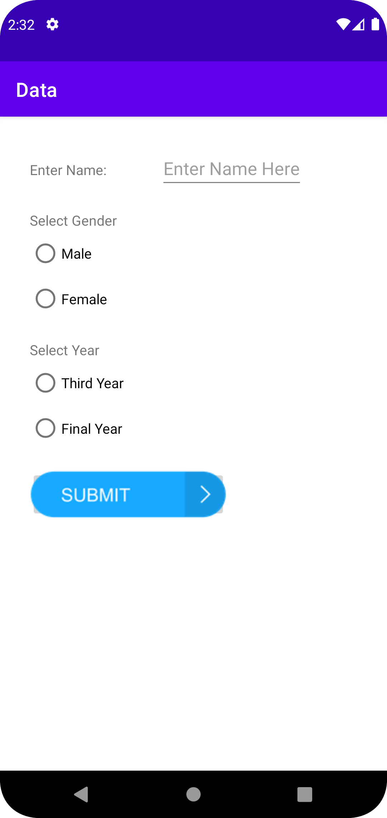

1. **On Button click, fetch the user entered values from all UI components and place them on a TextView in the same activity. (3 M)**

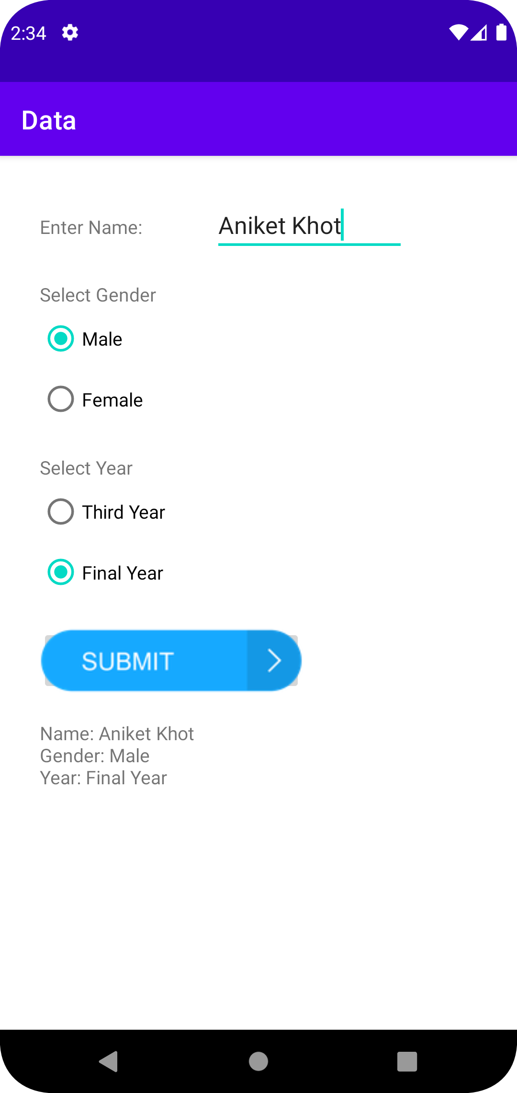

1. **On click of the Result TextView, switch from screen 1 to screen 2 and display a random message. (2 M)**

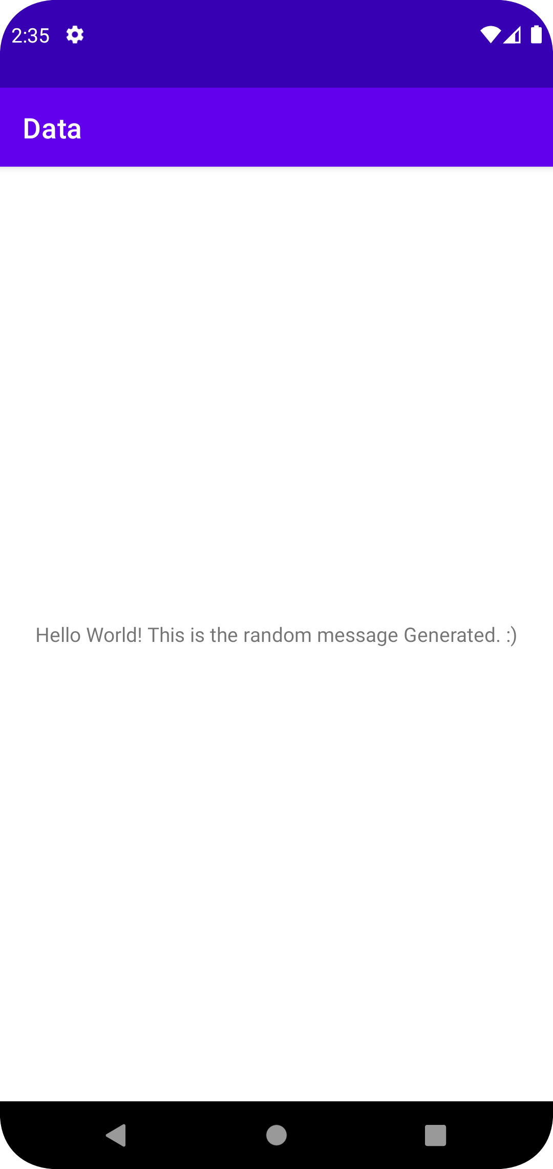

1. **Deploy the application on API 30. (1 M)**

Application is deployed on **Pixel 4 API 30**

